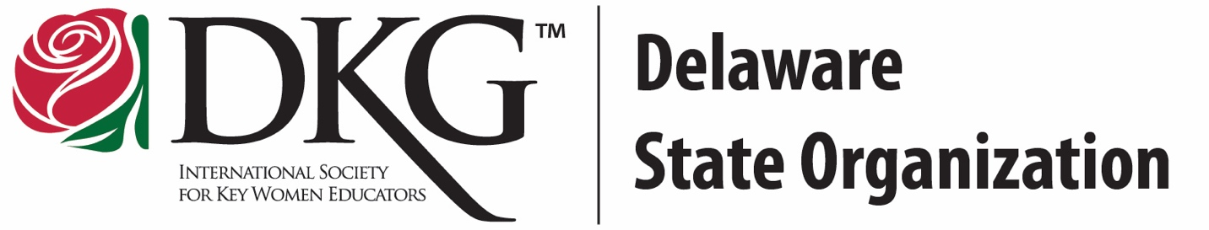
Delaware State Organization 2024 Women In the Arts Exhibit
Registration Deadline: April 12, 2024
Complete the registration form below to participate in the Delaware State Organization Women in the Arts Exhibit. The in-person show will be held at
our state conference at Maple Dale Country Club on Saturday, April 27, 2024.
Eligibility:
- The participant must be a member of the Delaware State Organization.
- Artwork must be the work of the registrant and completed within the last five years.
- Submit an image of the artwork along with the registration form to
Shannon White (shanlwhite98@gmail.com).
The Educational Excellence Committee reserves the right to disqualify entries they consider to be unacceptable or inappropriate for a public exhibit.
Rules of Exhibit:
- The registration form with an image of the artwork needs to be received by April 12, 2024.
- All artwork needs an identification label with the name and chapter of the participant placed on the back.
- Entries should be delivered to Maple Dale Country Club on April 27 between 8:15 am and 8:30 am.
- Artwork needs to be removed at the end of the conference. Neither the Educational Excellence Committee nor Maple Dale Country Club may be held responsible for unclaimed works.
- Every attempt will be made to preserve, secure, and protect each entry submitted; however, the Delaware State organization cannot be held responsible for damages, loss of art entries, or changes/cancellation of this exhibit due to low participation or unforeseen circumstances
- The Delaware State Organization reserves the right to publish reproductions of the entries for publicity purposes.
Delaware State Organization 2024 Women In the Arts Exhibit
Registration Form
Artist Information:
Name
Chapter
Street Address
City
State
Zip Code
Home Phone
Cell Phone
E-mail Address
Entry Information:
Entry Title:
Year Artwork Completed:
Medium (circle):
Painting Drawing Sculpture Photograph Metalwork Basketry Embroidery Poetry Music Other
Size of Artwork:
I have read and understand the rules of the exhibit.
Signature
Date
E-mail this form along with an image of your artwork to Shannon White at shanlwhite98@gmail.com by April 12.

